CBSE JUNIOR (MPC) TEST - 12

Total points47/60

ALL QUESTIONS ARE COMPULSORY. TIME: 2 HR  
NO NEGATIVE MARKING.  
EACH QUESTION CARRIES 1M.  
TOTAL-60 M.

Email address *

alasesaakshi@gmail.com

0 of 0 points

Student Name *

saakshi alase

Student ID : *

vncm2016

Section *

CJ1(HOSTLER)

CJ1(DAY SCHOLAR)

Phone number *

9538999110

MATHEMATICS

15 of 20 points

NO OF QUESTIONS - 20

1.

1/1

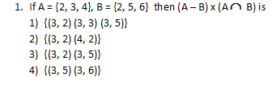

Option 1

Option 2

Option 3

Option 4

2.

1/1

Captionless Image

Option 1

Option 2

Option 3

Option 4

3.

0/1

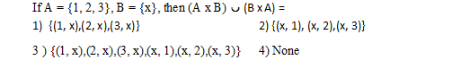

Option 1

Option 2

Option 3

Option 4

Correct answer

Option 2

4.

0/1

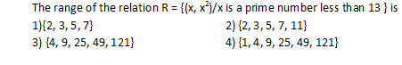

Option 1

Option 2

Option 3

Option 4

Correct answer

Option 4

5.

1/1

Captionless Image

Option 1

Option 2

Option 3

Option 4

6.

1/1

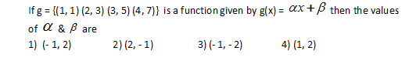

Option 1

Option 2

Option 3

Option 4

7.

0/1Captionless Image

Option 1

Option 2

Option 3

Option 4

Correct answer

Option 4

8.

0/1

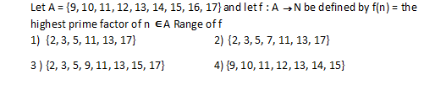

Option 1

Option 2

Option 3

Option 4

Correct answer

Option 1

9.

1/1

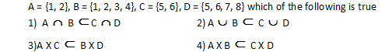

Option 1

Option 2

Option 3

Option 4

10.

1/1

Captionless Image

Option 1

Option 2

Option 3

Option 4

11.

1/1

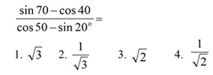

Option 1

Option 2

Option 3

Option 4

12.

1/1

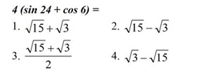

Option 1

Option 2

Option 3

Option 4

13.

0/1

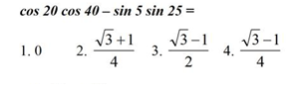

Option 1

Option 2

Option 3

Option 4

Correct answer

Option 2

14.

1/1

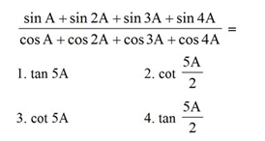

Option 1

Option 2

Option 3

Option 4

15.

1/1

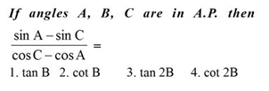

Option 1

Option 2

Option 3

Option 4

16

1/1

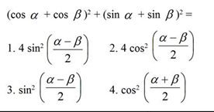

Option 1

Option 2

Option 3

Option 4

17.

1/1

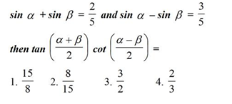

Option 1

Option 2

Option 3

Option 4

18.

1/1

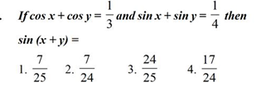

Option 1

Option 2

Option 3

Option 4

19.

1/1

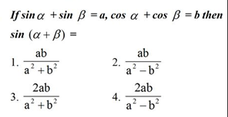

Option 1

Option 2

Option 3

Option 4

20.

1/1

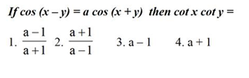

Option 1

Option 2

Option 3

Option 4

PHYSICS

19 of 20 points

NO OF QUESTIONS-20

21.A 6 kg ball strikes a vertical wall with a velocity 34 m/sec and rebounds with a velocity of 26 m/sec the impulse is

1/1

1) 60NS

2) 180NS

3) 48NS

4) 360NS

22.

1/1

Captionless Image

Option 1

Option 2

Option 3

Option 4

23.

1/1

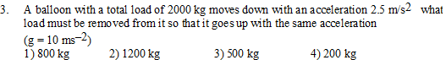

Option 1

Option 2

Option 3

Option 4

24.

1/1

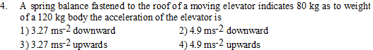

Option 1

Option 2

Option 3

Option 4

25.

1/1

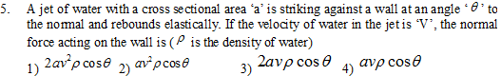

Option 1

Option 2

Option 3

Option 4

26.

1/1

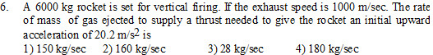

Option 1

Option 2

Option 3

Option 4

27.

1/1

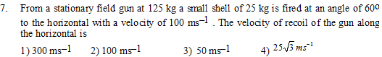

Option 1

Option 2

Option 3

Option 4

28.

1/1

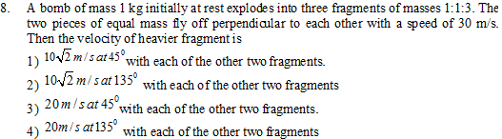

Option 1

Option 2

Option 3

Option 4

29.

1/1

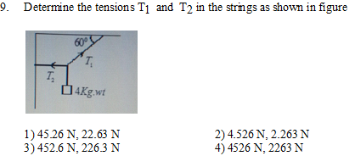

Option 1

Option 2

Option 3

Option 4

30.

1/1

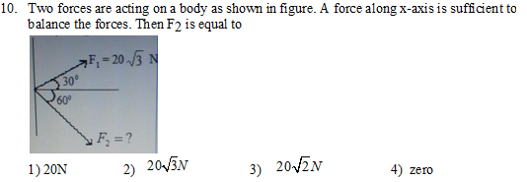

Option 1

Option 2

Option 3

Option 4

31.

1/1

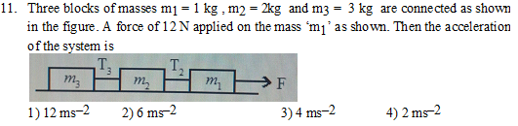

Option 1

Option 2

Option 3

Option 4

32.

1/1

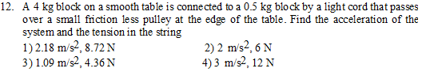

Option 1

Option 2

Option 3

Option 4

33.

1/1

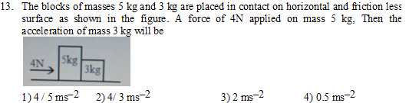

Option 1

Option 2

Option 3

Option 4

34.

1/1

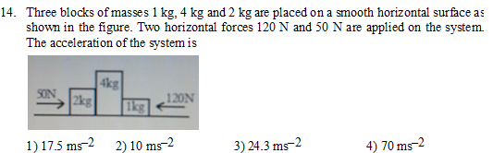

Option 1

Option 2

Option 3

Option 4

35.

1/1

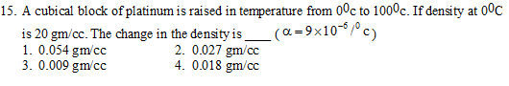

Option 1

Option 2

Option 3

Option 4

36.

0/1

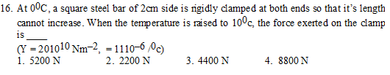

Option 1

Option 2

Option 3

Option 4

Correct answer

Option 4

37.

1/1

Captionless Image

Option 1

Option 2

Option 3

Option 4

38.

1/1

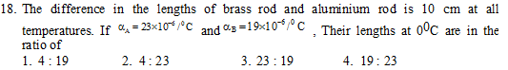

Option 1

Option 2

Option 3

Option 4

39.

1/1

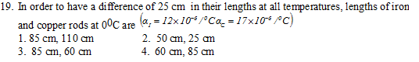

Option 1

Option 2

Option 3

Option 4

40.

1/1

Captionless Image

Option 1

Option 2

Option 3

Option 4

CHEMISTRY

13 of 20 points

NO OF QUESTIONS-20

41.

1/1

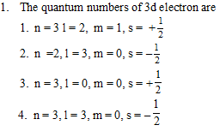

Option 1

Option 2

Option 3

Option 4

42. Capacity of all the orbitals with l=3 are

0/1

1. 2

2. 14

3. 7

4. 10

Correct answer

2. 14

43. The number of radial nodes present in the radial probability distribution curves for the Orbital wave function with quantum numbers n = 4, l = 0 and m = 0 is

1/1

1. 4

2. 3

3. 2

4. 1

44.

1/1

Captionless Image

Option 1

Option 2

Option 3

Option 4

45.

1/1

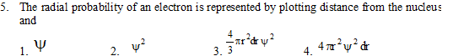

Option 1

Option 2

Option 3

Option 4

46.

1/1

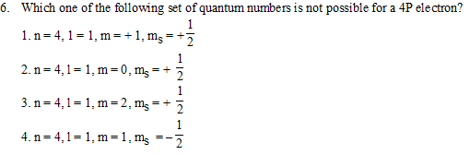

Option 1

Option 2

Option 3

Option 4

47.

1/1

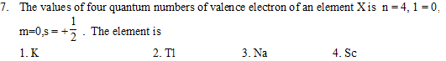

Option 1

Option 2

Option 3

Option 4

48.

1/1

Captionless Image

Option 1

Option 2

Option 3

Option 4

49.

1/1

Captionless Image

Option 1

Option 2

Option 3

Option 4

50. There is no differrence between 2p and 3p orbital regarding

0/1

1) value of ‘n’

2) size

3) energy

4) shape

Correct answer

4) shape

51. Which of the following is indicated by magnetic quantum number

1/1

1) size

2) shape

3) spatial orientation

4) spin

52. The maximum number of electrons in a sub shell is given by the expression

1/1

1) (l+2)

2) (2l + 2)

3) (4l + 2)

4) (l + 1)

53. The atomic radii in case of inert gases is

1/1

1. ionic radii

2. covalent radii

3. van der Waal’s radii

4. crystal radii

54.

0/1

Captionless Image

Option 1

Option 2

Option 3

Option 4

Correct answer

Option 3

55. Which of the following is truly transition element?

0/1

1. zinc

2. cerium

3. calcium

4. Cobalt

Correct answer

4. Cobalt

56.

1/1

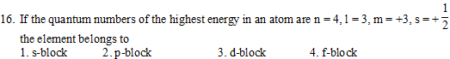

Option 1

Option 2

Option 3

Option 4

57.

1/1

Captionless Image

Option 1

Option 2

Option 3

Option 4

58.

0/1

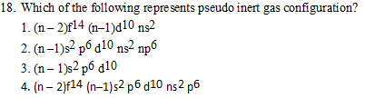

Option 1

Option 2

Option 3

Option 4

Correct answer

Option 3

59. What is wrong about transition metals?

0/1

1. They are diamagnetic

2. They are paramagnetic

3. They form complexes

4. They show variable oxidation state

Correct answer

1. They are diamagnetic

60.

0/1

Captionless Image

Option 1

Option 2

Option 3

Option 4

Correct answer

Option 2

This content is neither created nor endorsed by Google. - [Terms of Service](https://policies.google.com/terms) - [Privacy Policy](https://policies.google.com/privacy)

[Forms](https://www.google.com/forms/about/?utm_source=product&utm_medium=forms_logo&utm_campaign=forms)